Computer Programming  
Lab Tasks



Department of Computer Science - BUIC

Name: Saad Ahmad

Enrollment Number: 01-134222-130

**Exercises/Lab Journal 6**

**Task 1**. Dry-run the following code, write the output and explain each step:

int i = 5; ( i is declared and initialized to 5.)

i*=i++; (i=i*i++ first i is multiplied by i and since post-increment sign is used then 1 is added to i*i which is 25, so the value of I becomes 26)

int numbers[ ]={ 3,4,7,9,8,11,6, 12, 14, 10 }; ( An array(numbers) of size 11 is declared and 11 different values are initialized)

cout << numbers[++i]-- << endl;

(In this statement i is incremented first due to the pre-increment sign and its value becomes 27 then it prints a garbage value because the length of the is 11 and we are trying to access the 27th index, after printing the value,1 is subtracted from the garbage value).

cout << numbers[i-5] << endl;

(In this statement 5 is subtracted from I which was 27, it gives the answer 22. However, the value 22 was not assigned to i so the value of i is still 27. Now again the array size is 11 and it’s trying to access the 22nd index so it will print a garbage value)

Output:

468 ( Garbage)

0 (Garbage)

**Task 2**. Complete the code of the following program as mentioned in the comments and display the output of the highest and lowest values of the array after changing its values as given below.

#include<iostream>

using namespace std;

int main()

{

// Define correct variable for the size of the array.

const int SIZE = 10;

int numbers[SIZE] = { 3,4,7,9,8,11,6, 12, 14, 10 };

int largest;

int lowest;

int i;

// The following code will change the values of the above array.

for (int count = 0; count < SIZE; count++) {

numbers[count] = numbers[count] + 5 * 2;

}

lowest = numbers[0];

for (i = 0; i < SIZE;i++){

if (lowest > numbers[i]) {

lowest = numbers[i];

}

}

cout << "The lowest value in the array is : " << lowest << endl;

largest = numbers[0];

for (i = 0; i < SIZE; i++) {

if (largest < numbers[i]){

largest = numbers[i];

}

}

cout <<"The largest value in the array is : " << largest << endl;

// define variables to find the second largest value and the second lowest value

int second_largest;

int second_lowest;

// write the code to find the second largest value in the above array after changes.

second_largest = largest;

for (i = 0; i < SIZE; i++) {

if (second_largest == numbers[i]) {

numbers[i] = lowest;

}

}

second_largest = numbers[0];

for (i = 0; i < SIZE; i++) {

if (second_largest < numbers[i]) {

second_largest = numbers[i];

}

}

cout << "The second largest value in the array is: " << second_largest << endl;

// write the output of the above statement here: 22

// write the code to find the second lowest value in the above array after changes. Write second at the end of the paper for bonus.

second_lowest = lowest;

for (i = 0; i < SIZE; i++) {

if (second_lowest == numbers[i]) {

numbers[i] = largest;

}

}

second_lowest = numbers[0];

for (i = 0; i < SIZE; i++) {

if (second_lowest > numbers[i]) {

second_lowest = numbers[i];

}

}

cout << "The second lowest value in the array is: " << second_lowest;

// write the output of the above statement here: 14 */

return 0;

}

//second?

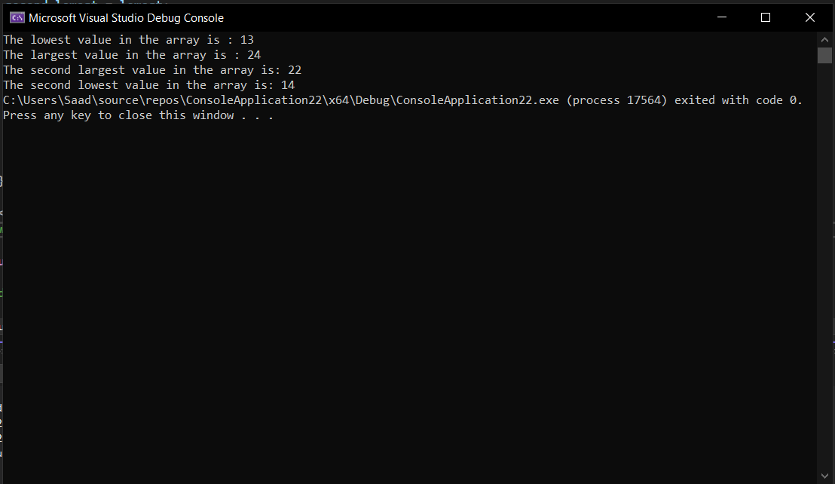

**Task 3**. Write a C++ program to find and print all common elements in three sorted arrays of integers.

#include <iostream>

using namespace std;

int main()

{

const int size = 5;

int array1[size] = { 10,20,30,50,80 };

int array2[size] = { 20,40,50,80,100};

int array3[size] = {20,30,50,80,100};

for (int i = 0; i < size; i++) {

for (int j = 0; j < size; j++) {

if(array1[i]==array2[j])

{

for (int k = 0; k < size; k++) {

if (array2[j] == array3[k]) {

cout << array1[i] << endl;

}

}

}

}

}

return 0;

}

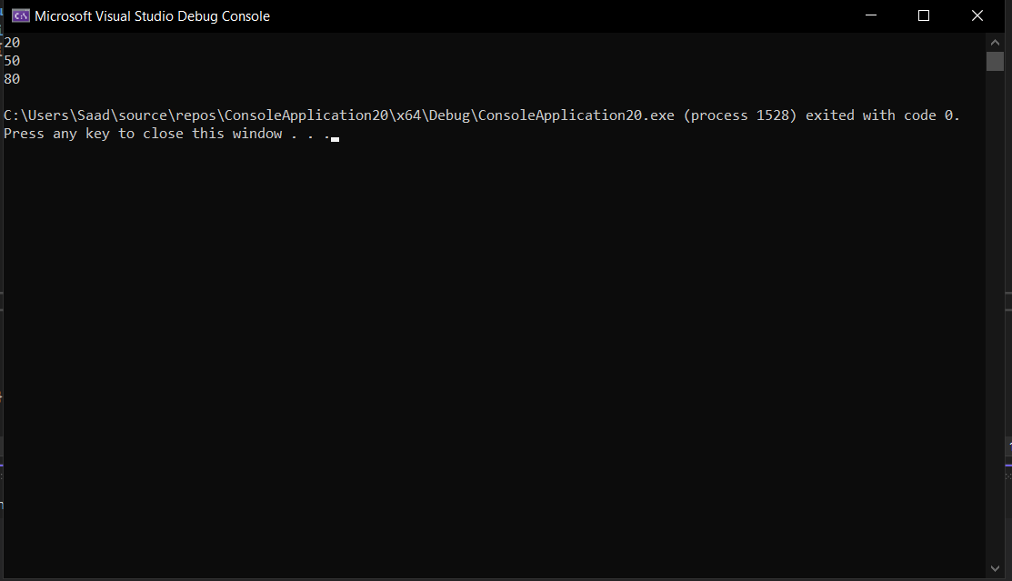

**Task 4.** Write the output of each statement of the following program as mentioned.

#include <iostream>

using namespace std;

int main()

{

int i = 2;

int array[] = {5,2,3,10,7};

cout << ++array[i] << endl; // write output here: 4

cout << array[++i]++ << endl; // write output here:10

cout << array[i] << endl; // write output here: 11

cout << 3-array[i] << endl; // write output here: -8

cout << array[i-5] << endl; // write output here: Garbage(-858993460)

return 0;

}